MOCKMVC TESTING

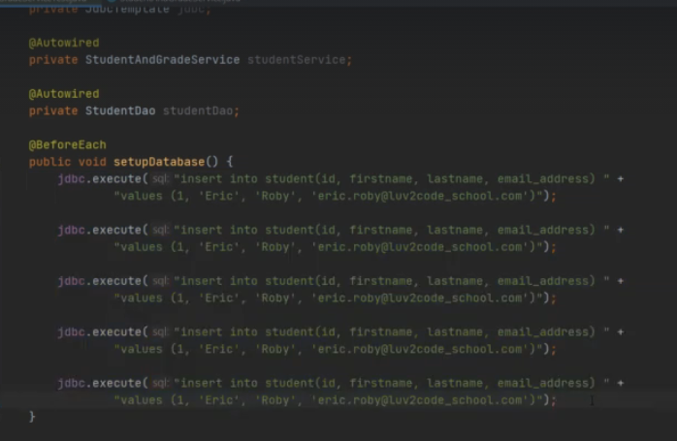

To make a query to the database what we can do is that we can execute the qury by autowiring the jdbc template and using its object.

Now some entries will be made in to our db.

We can also make a file known as infodata.sql

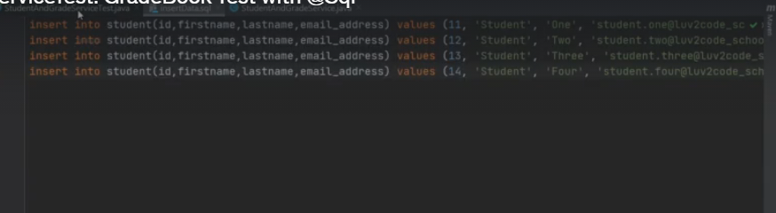

And now we can use this file to ut data in db.

We can call the file using the annotation

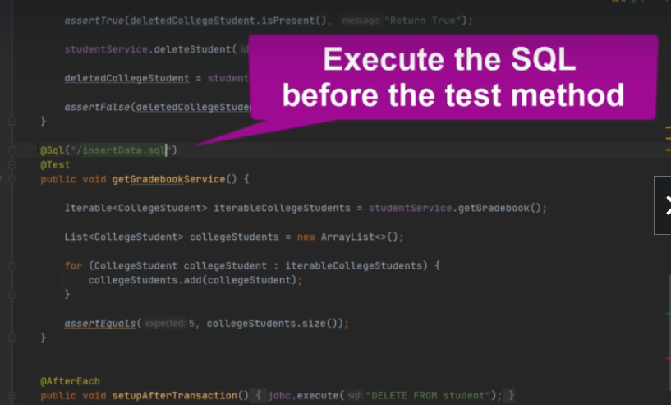

**TESING THE MVC CONTROLLERS**

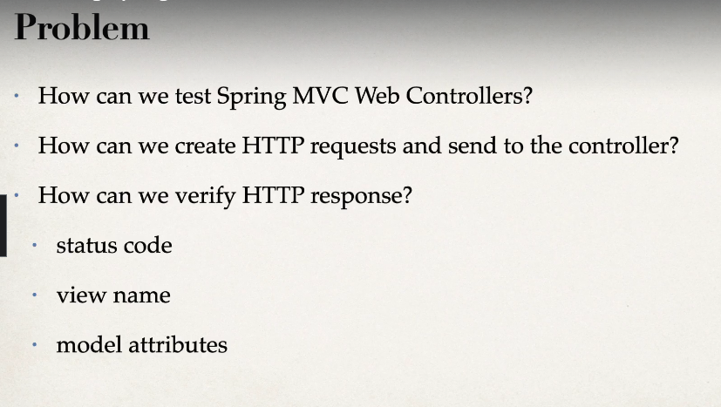

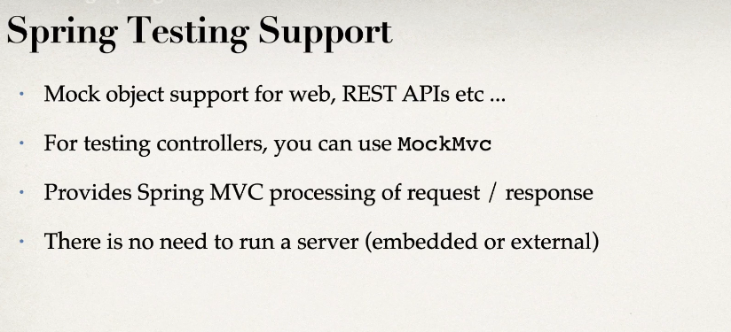

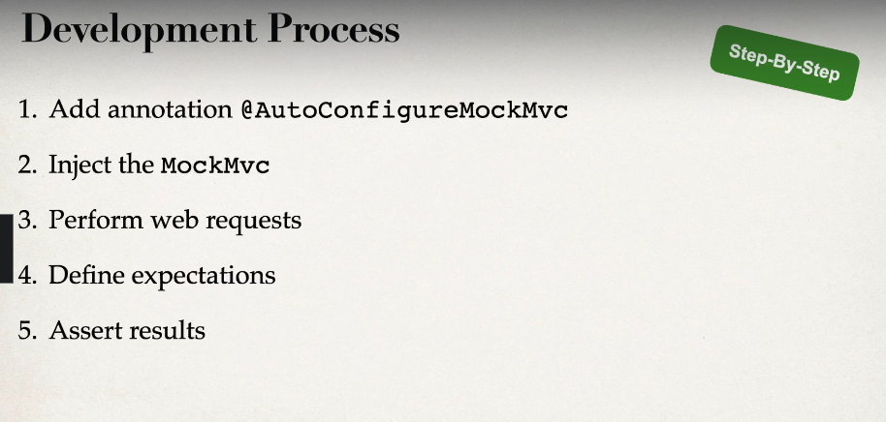

**Example**

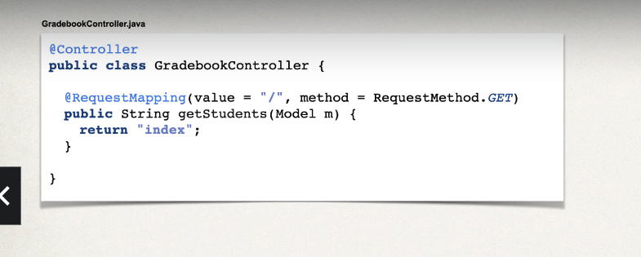

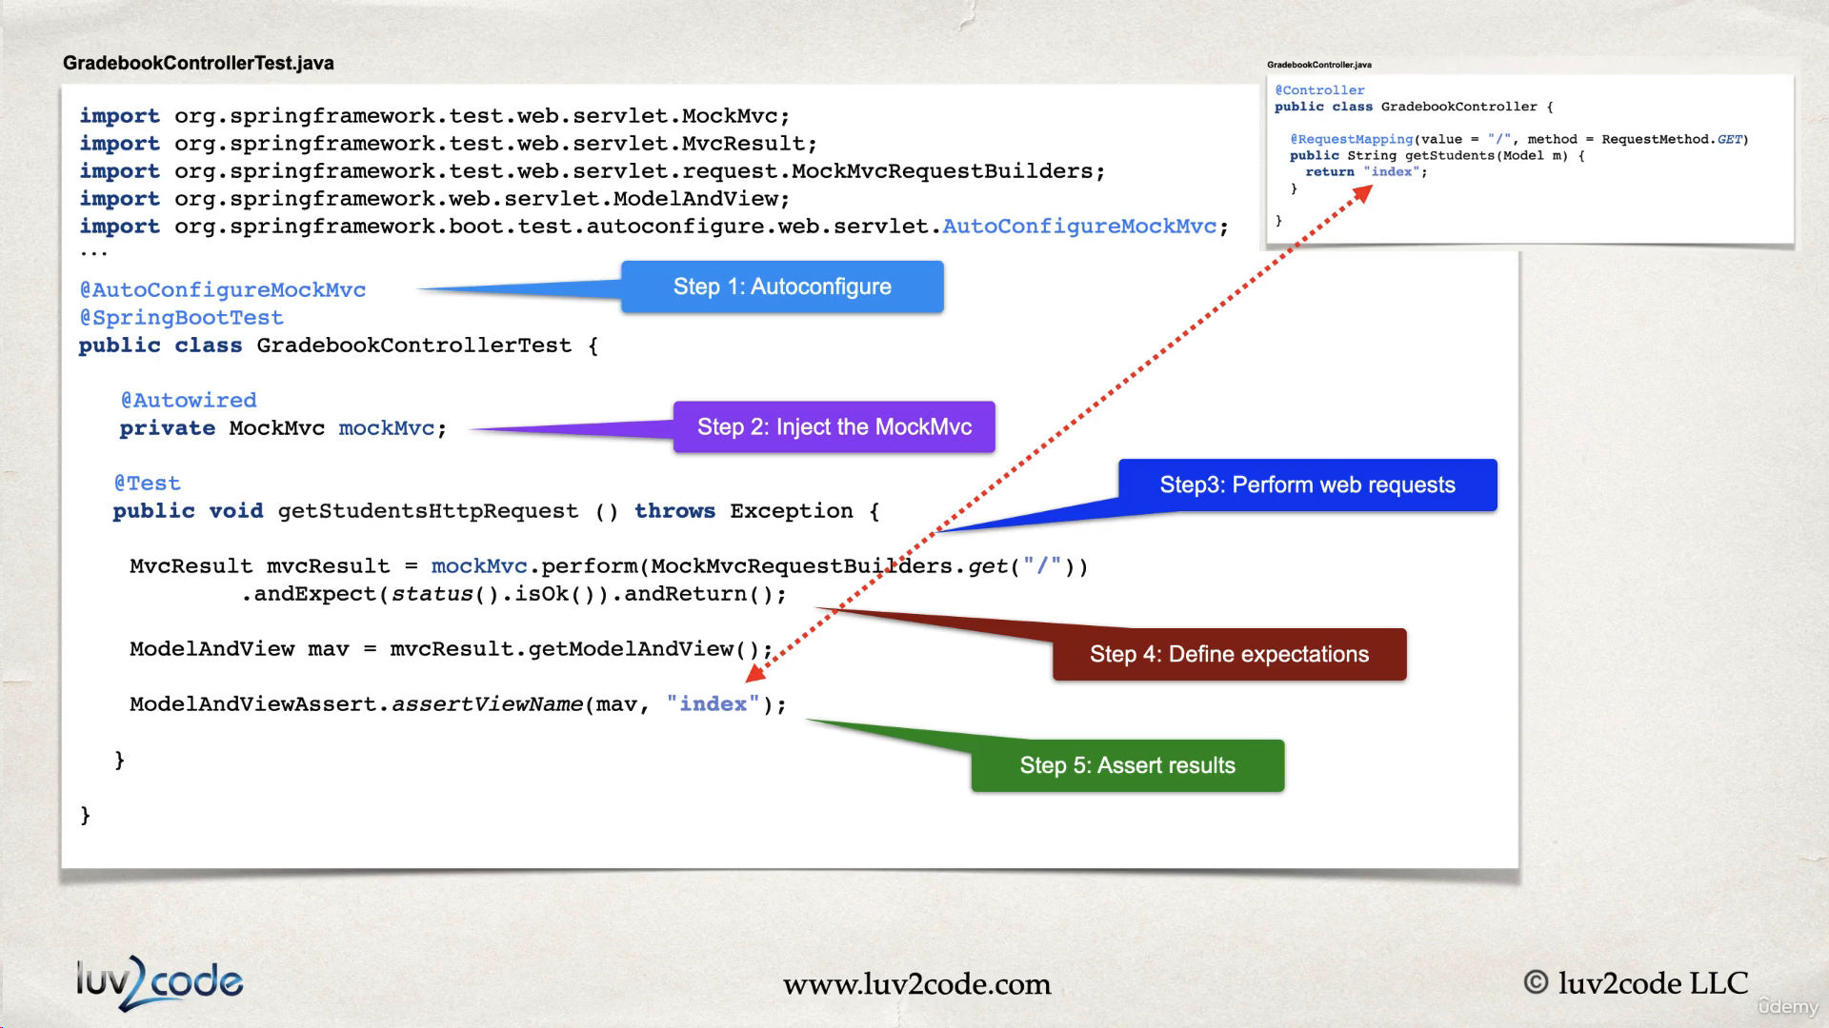

**CODING THE TEST FOR RESTCONTROLLER**

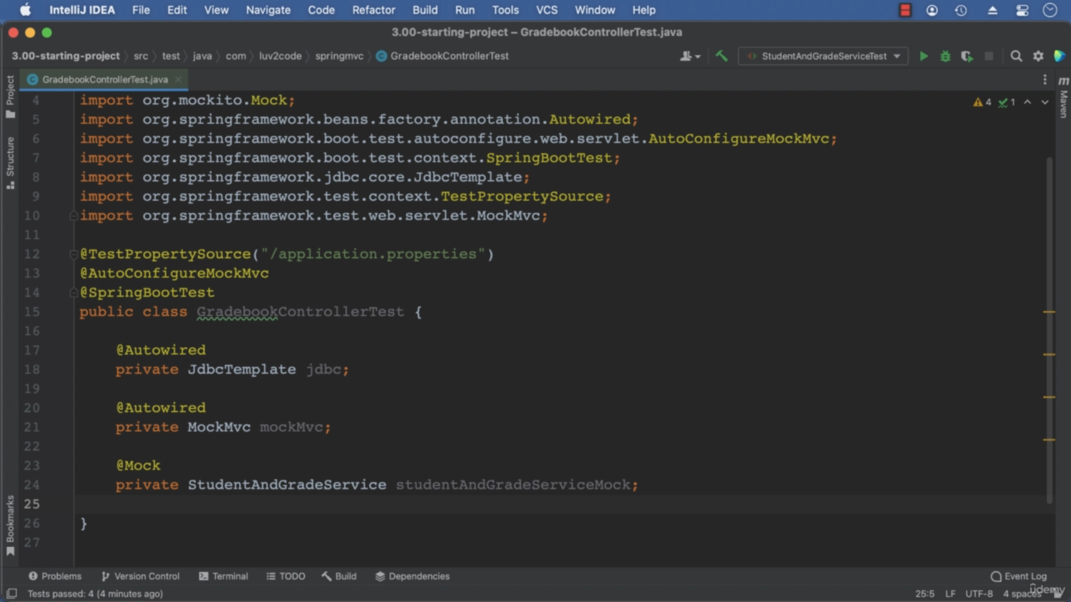

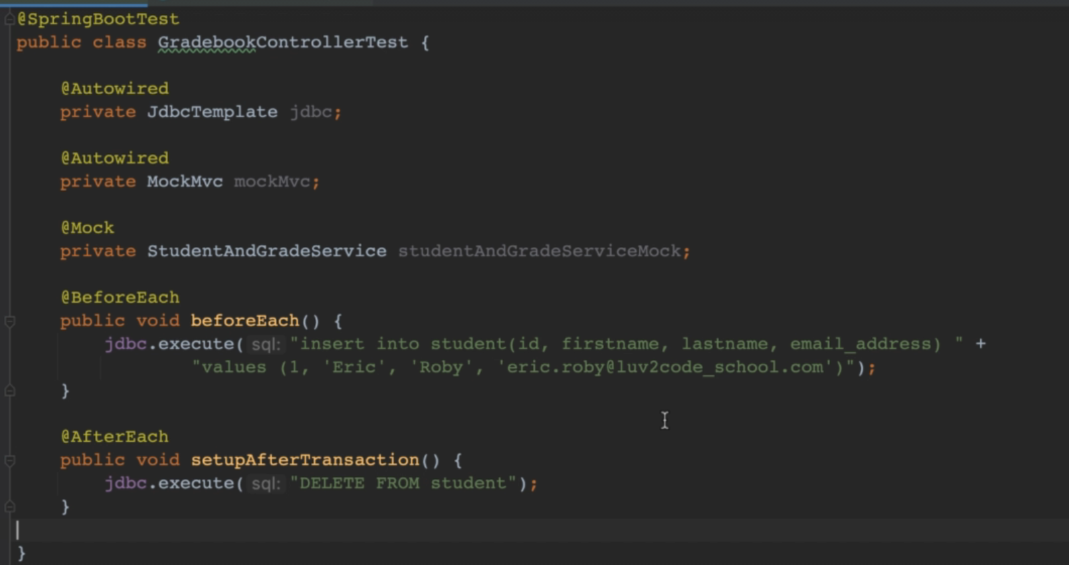

**Below is our controller class which needs to be tested**

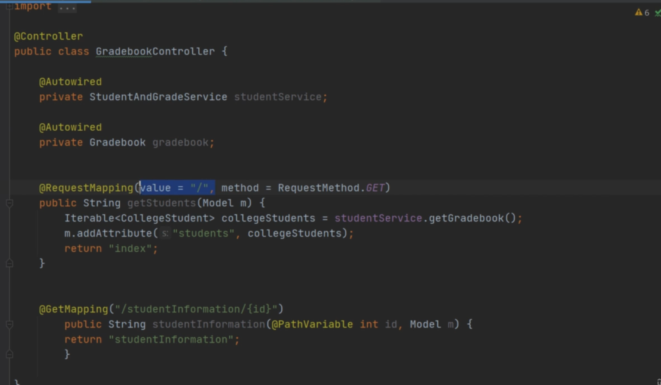

We write the below test for thes same

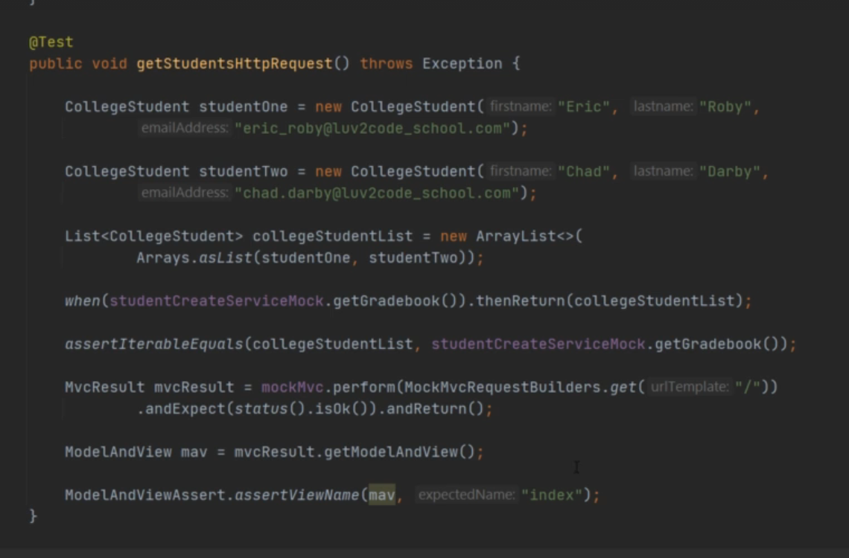

**POST REQUEST** **MEANS PUTTINGA STUDENT INTO THE DATABSE USING THE DAO LAYER**

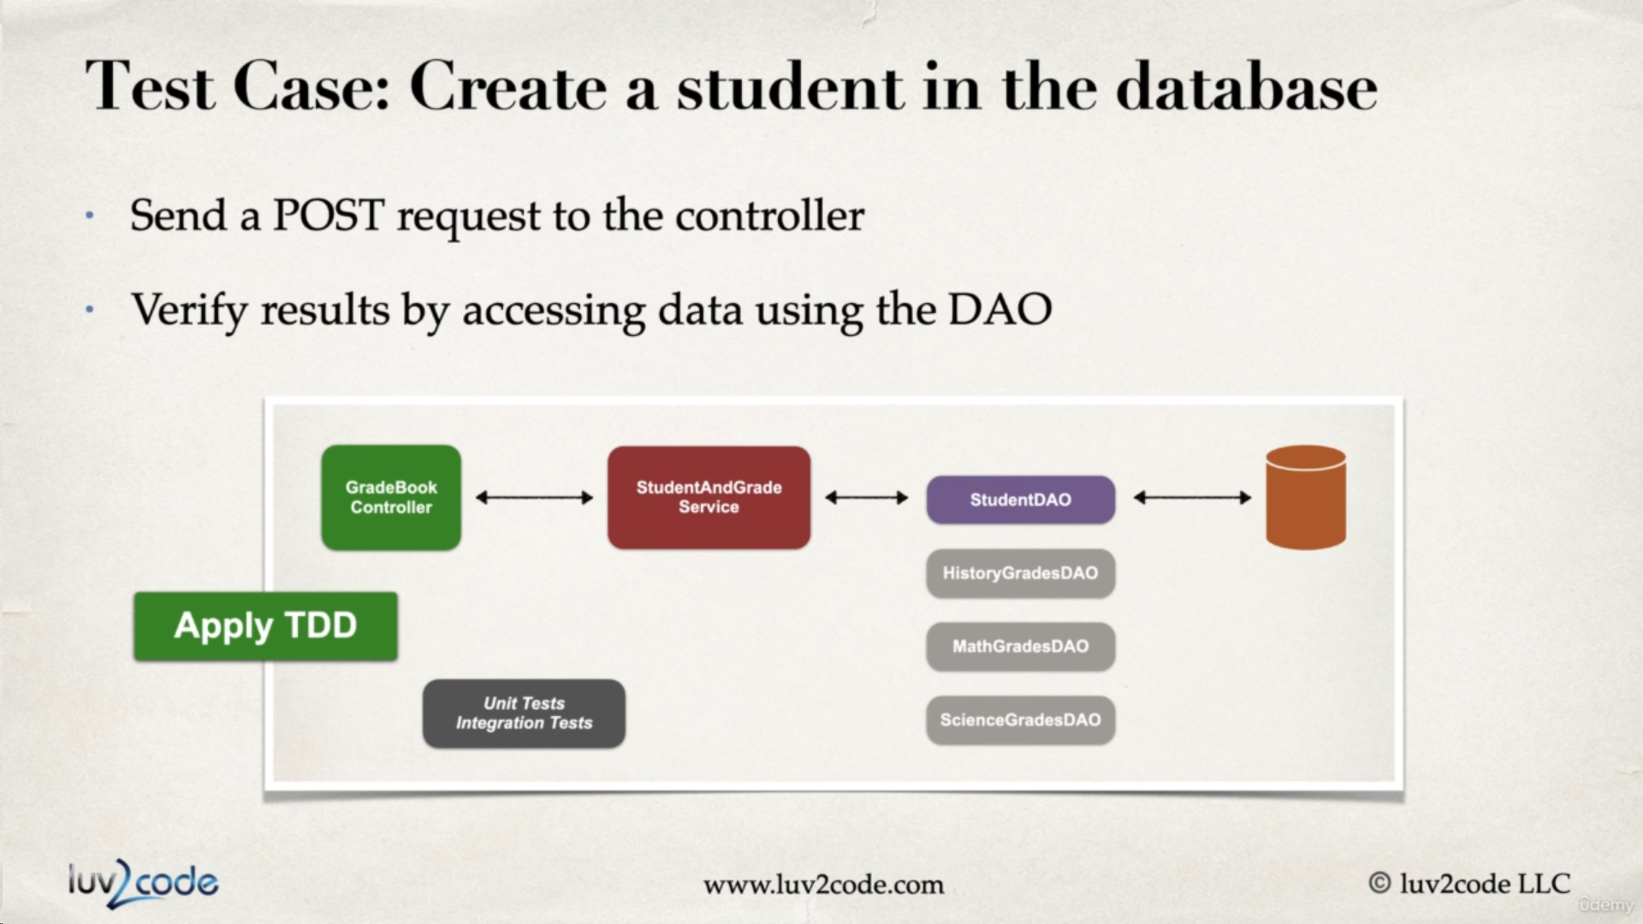

For making a call for a post request we have to make an object that need sto be stored in the beforeeach method

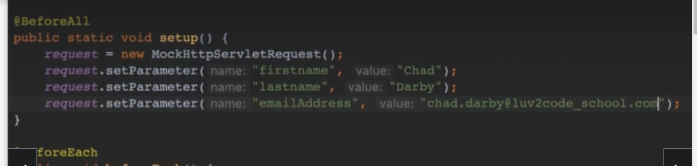

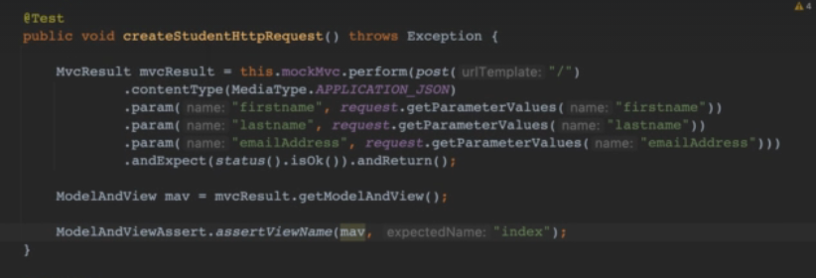

The above test failed

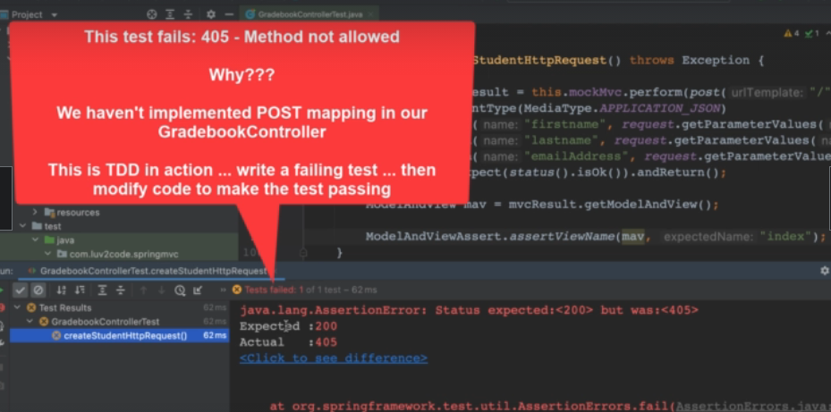

Since above is incomplete

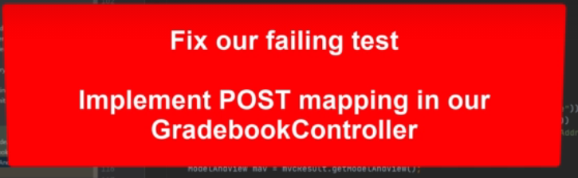

Move to controller and add a post mapping in controller

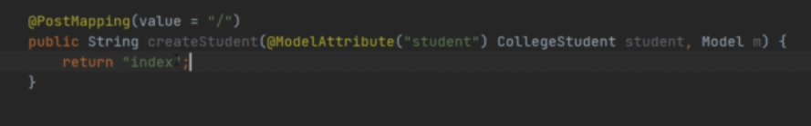

Now the above test will pass now.

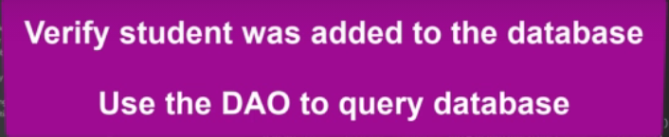

Autowire studentdao

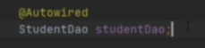

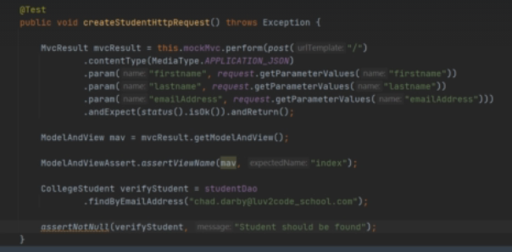

In our controller we update the code as

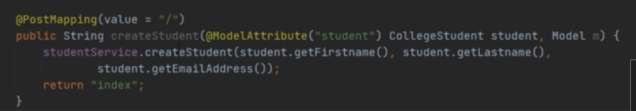

GET STUDENTS

The controller code is

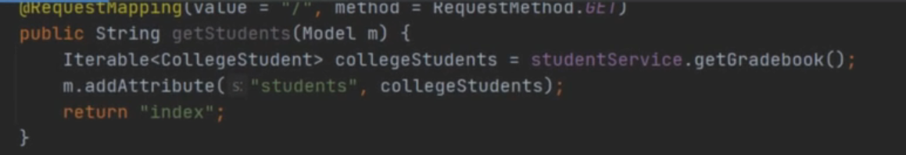

Updated put test is

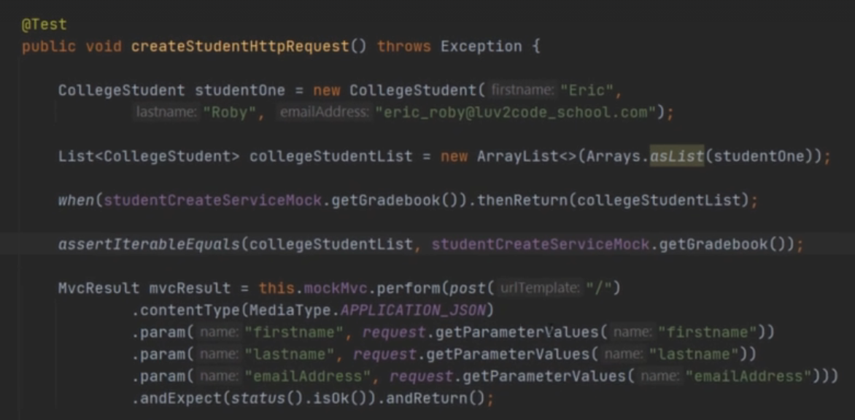

**DELETE A STUDENT TEST**

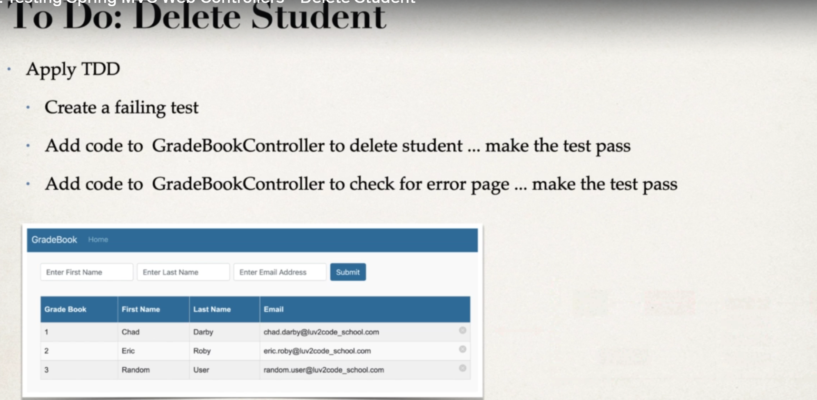

**First we will add a student into the database**

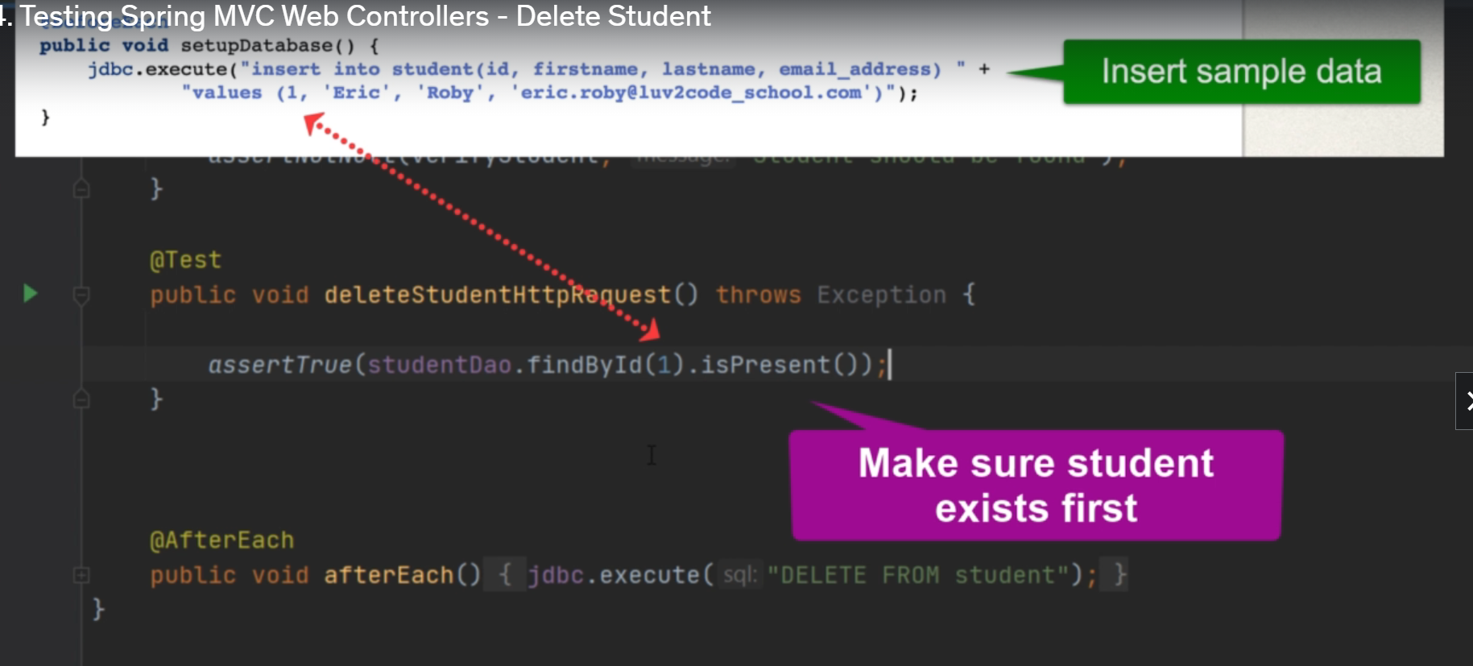

**The test case is as below:**

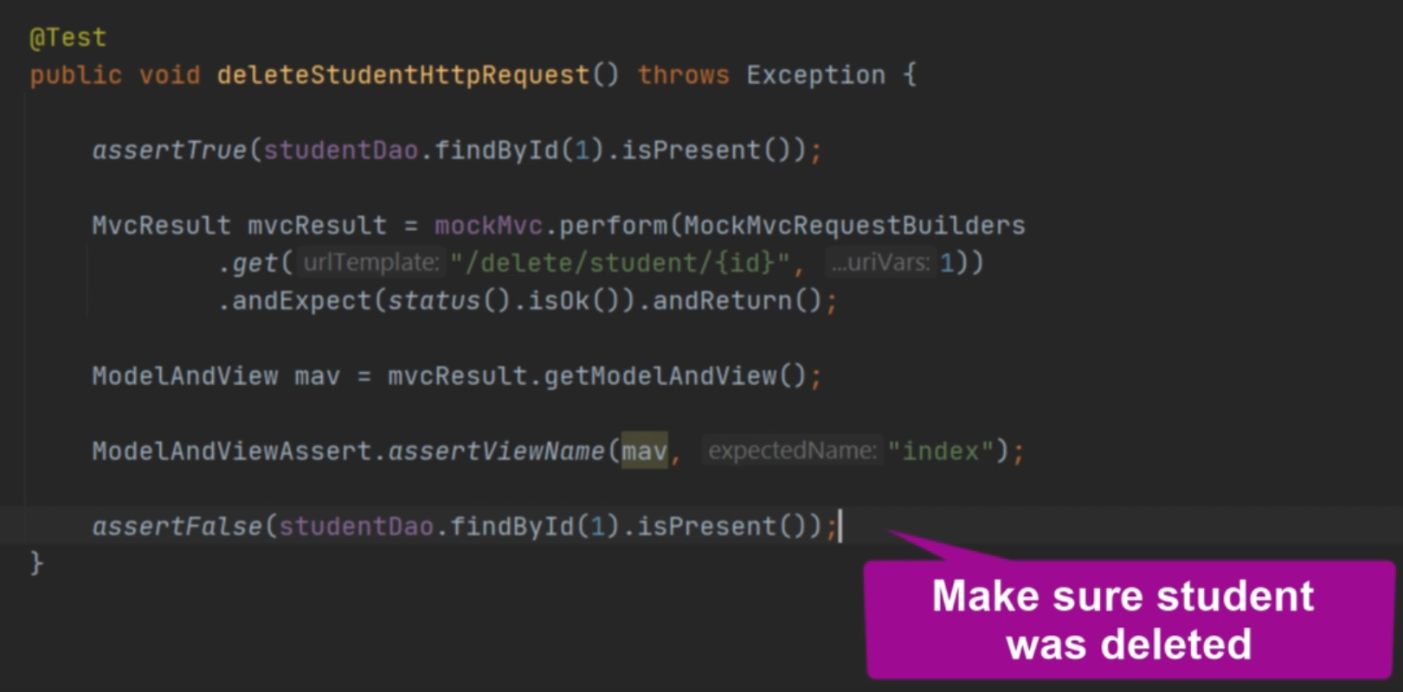

**We have the below code in our controller**

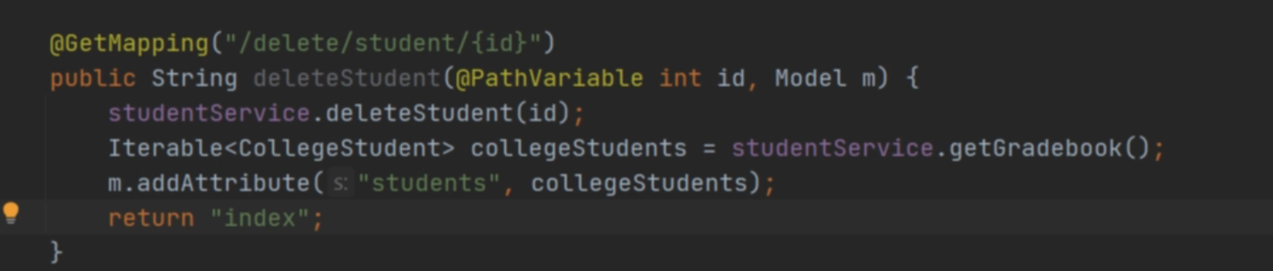

TDD  **TO ADD THE STUDENT GRADES**

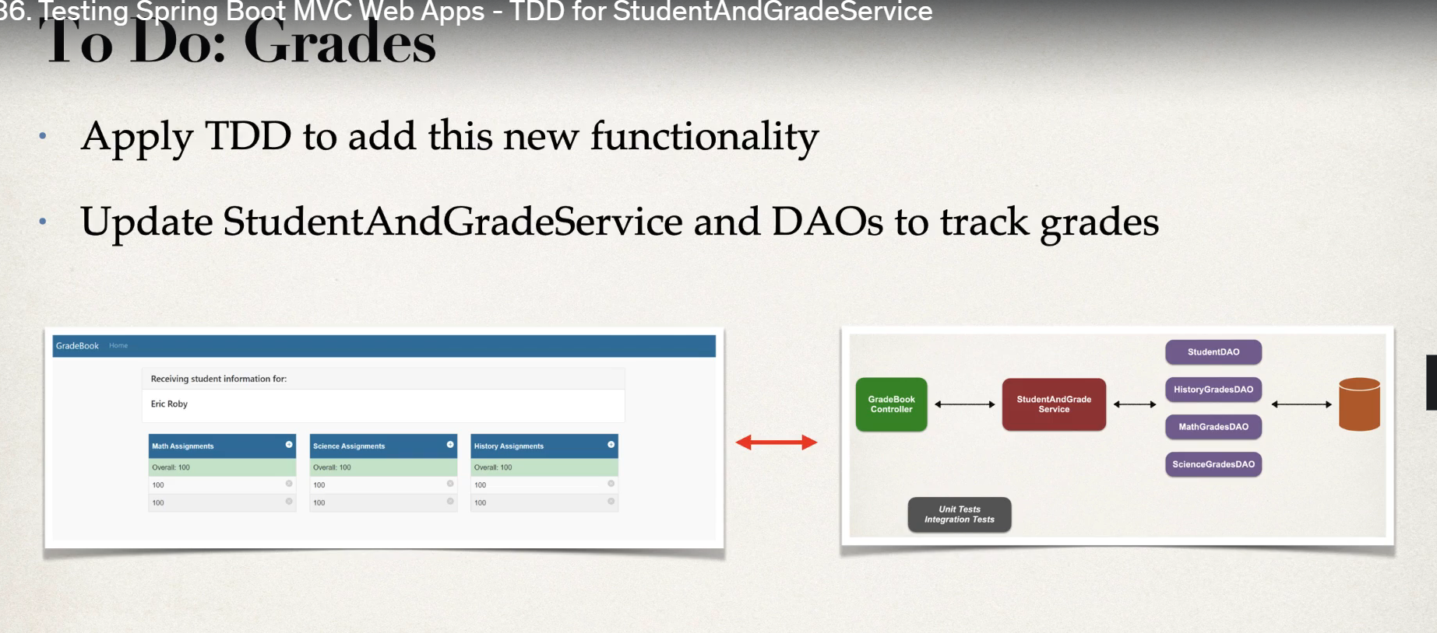**\**

**Now we**  will move onto another test clas

And add the below code

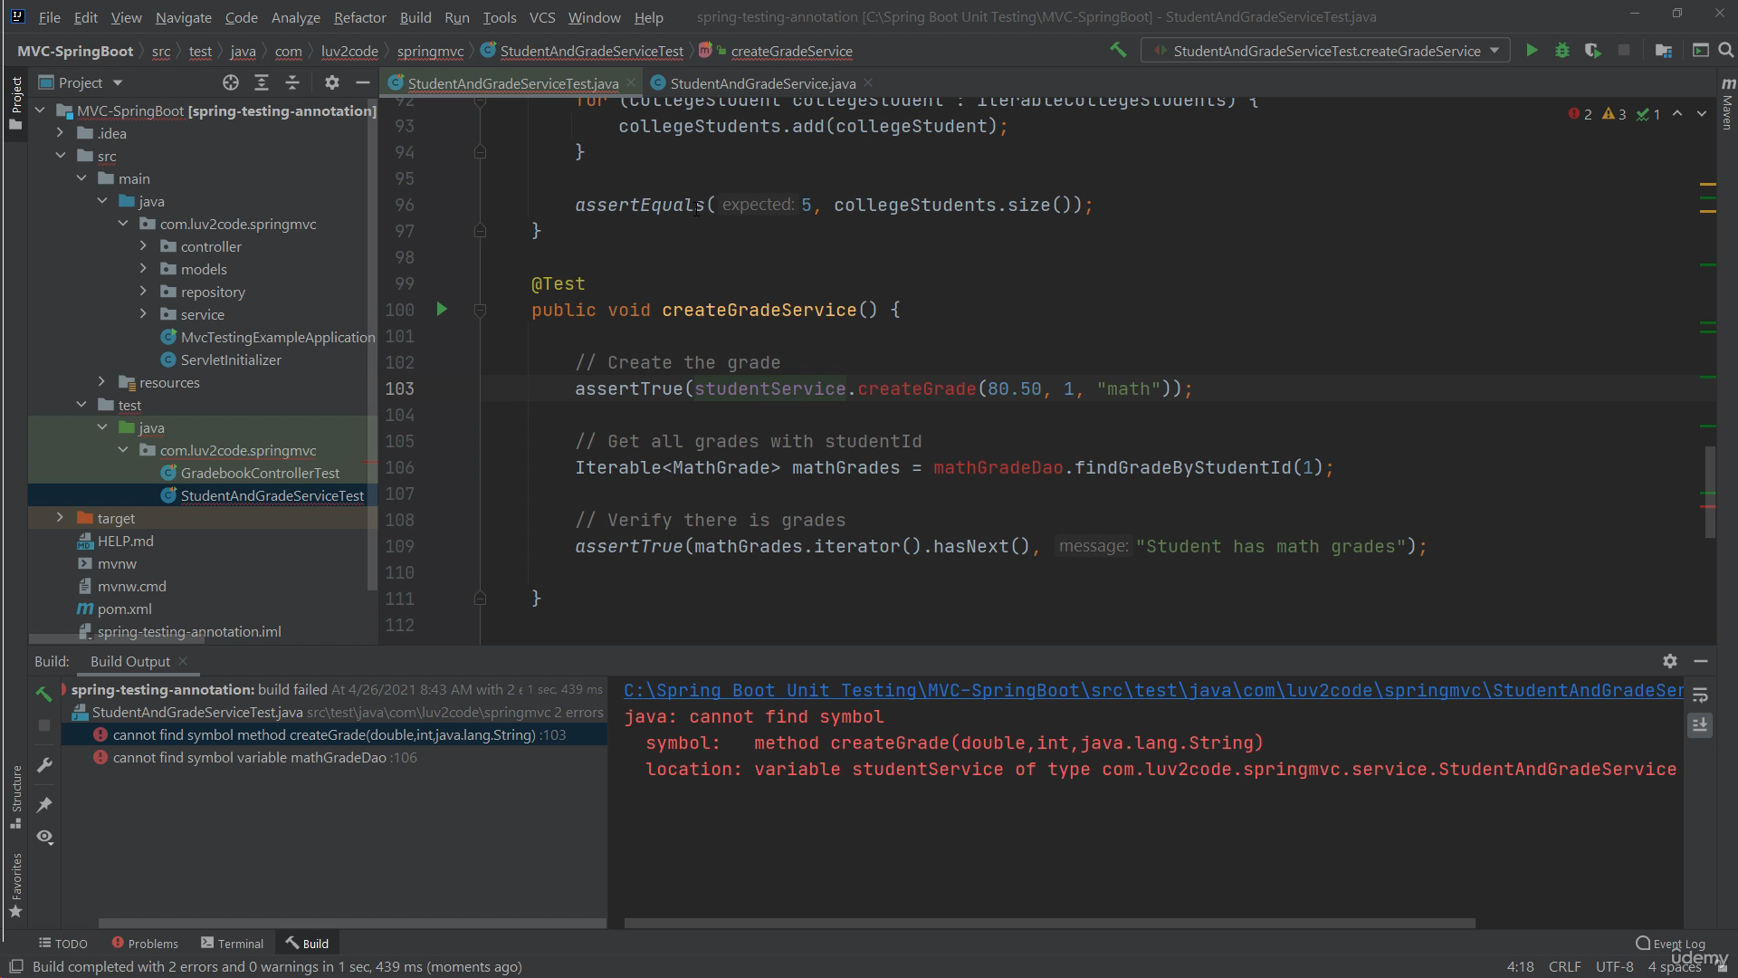

In the creategrade service write the below code

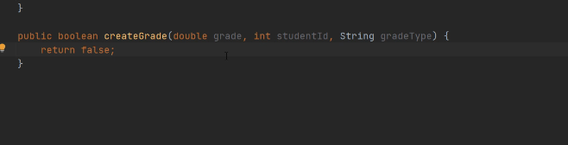

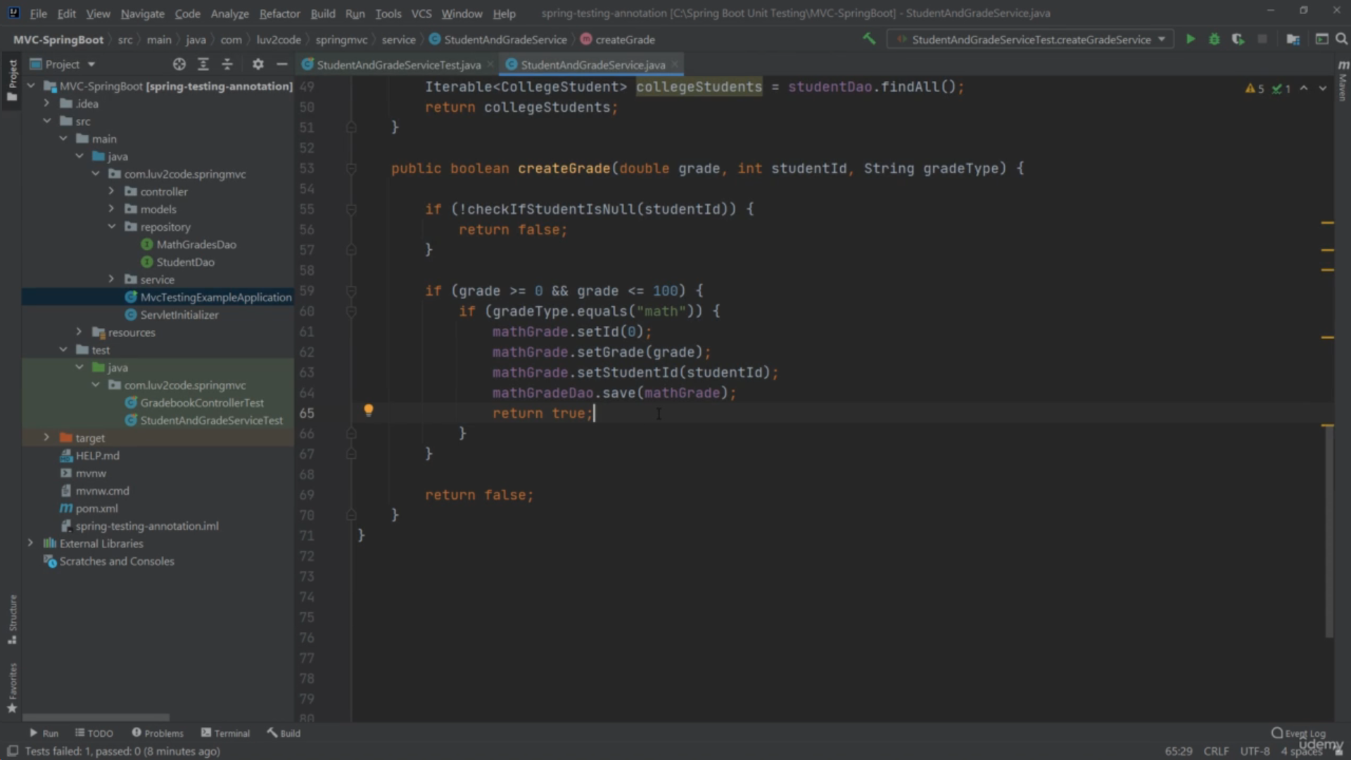

This Is the test for the above

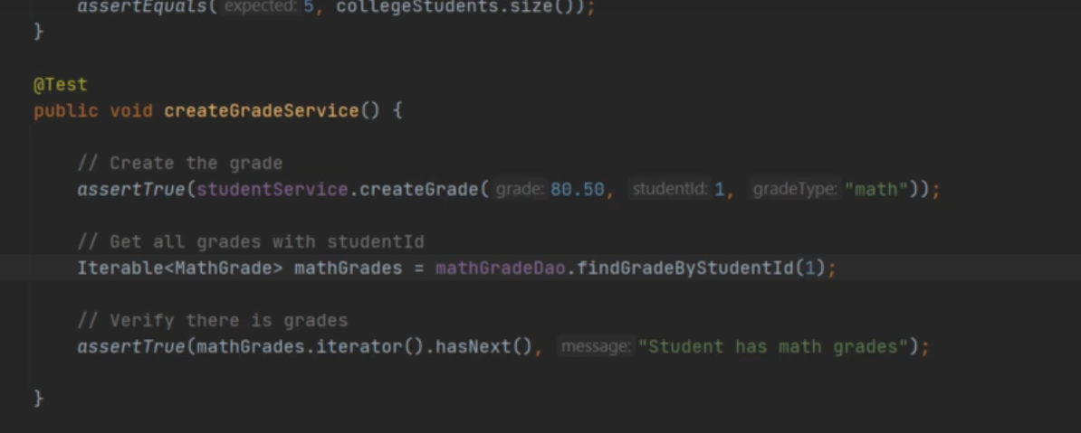

DELETE A GRADE

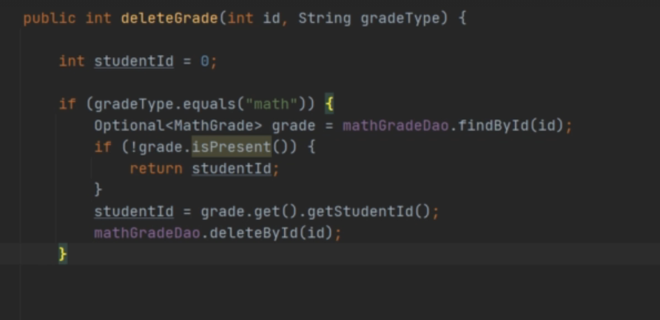

TEST CASE

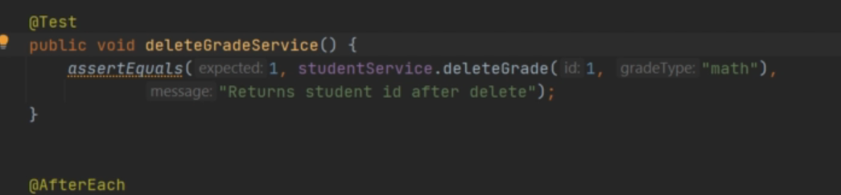

**TAKING SQL FROM @BEOFR AND AFTER EACH AND PUT IT IN THE PROPERTIES FILE**

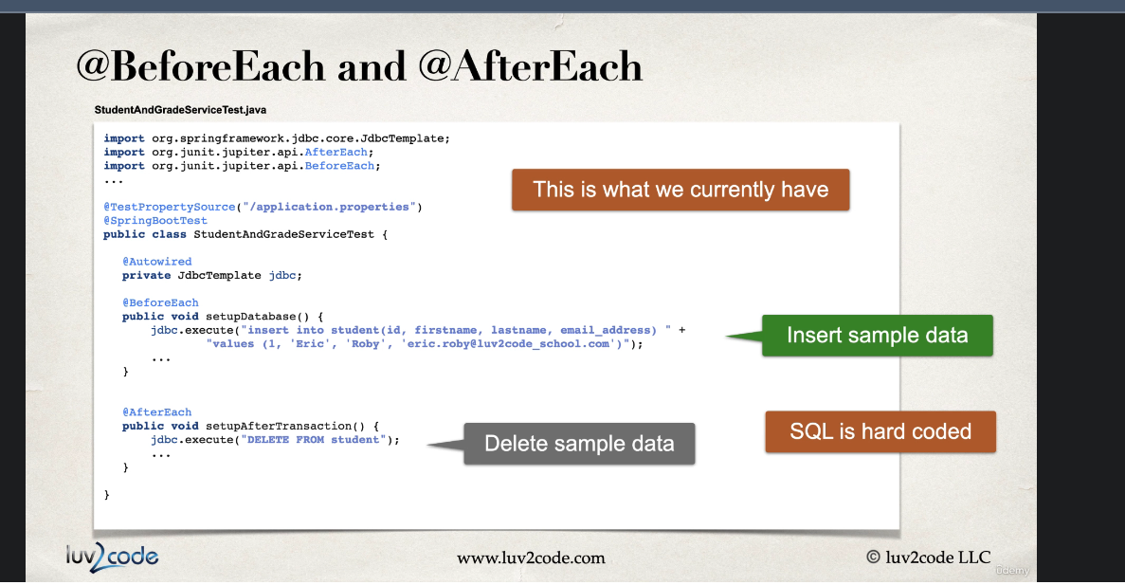

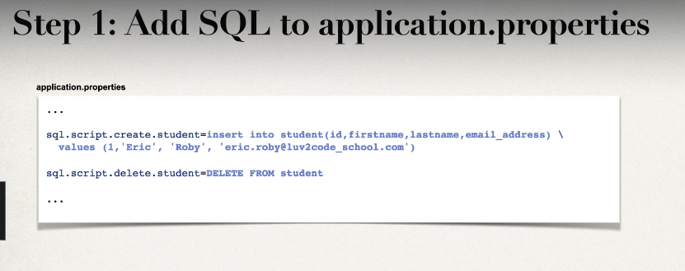

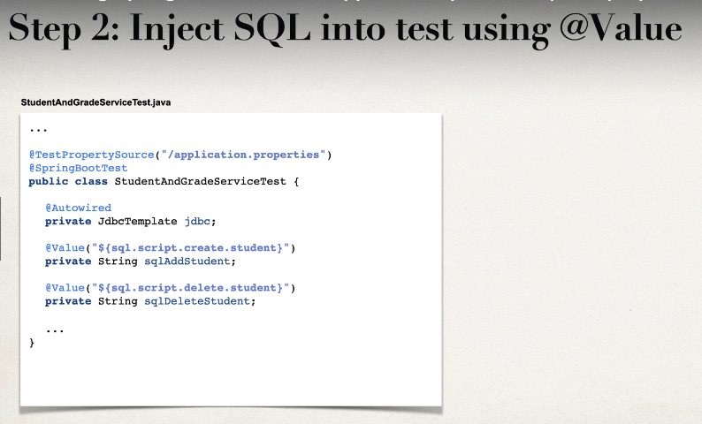

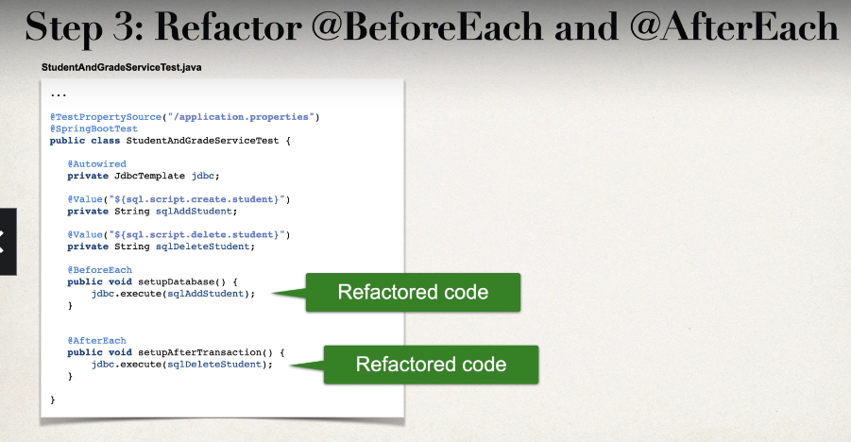

**We have amethod that gets us student information in controller**

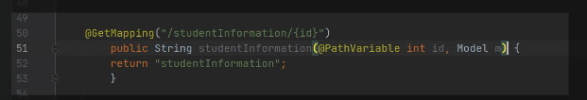

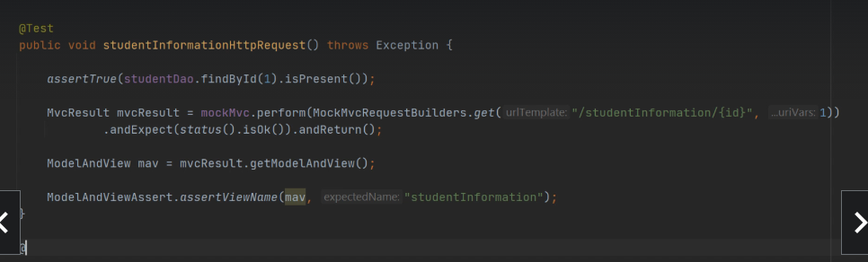

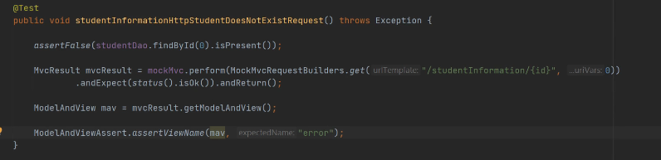

**Controller**

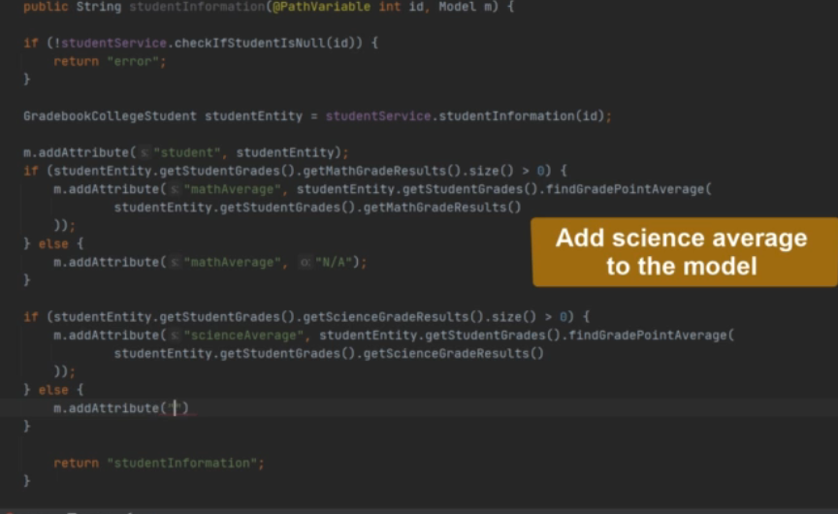

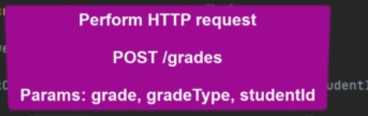

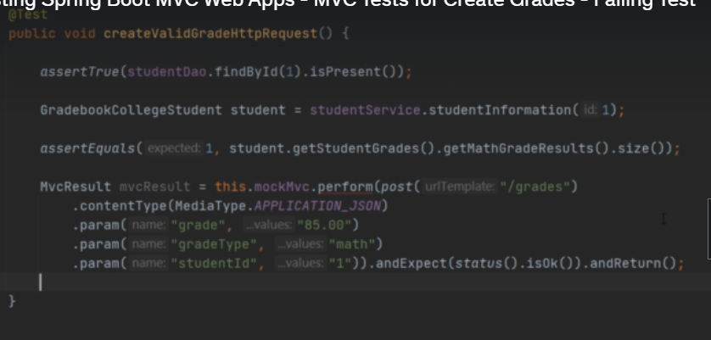

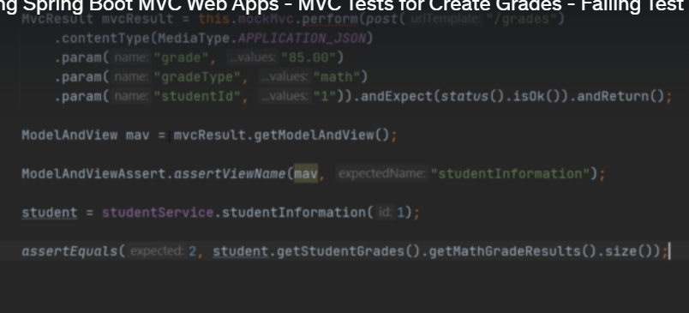

**Now in controller make the above method**

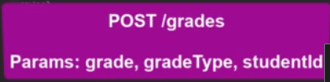

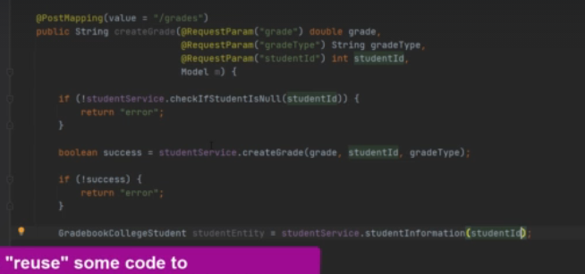

**Error page**

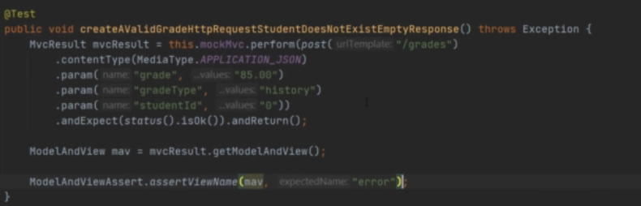

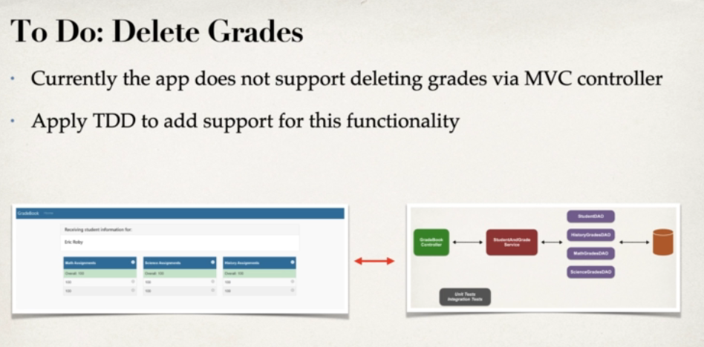

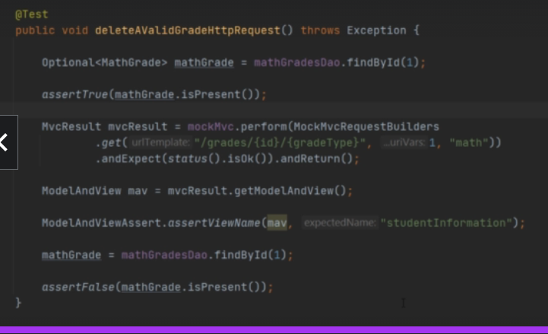

**Controller**

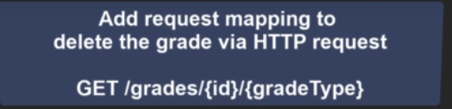

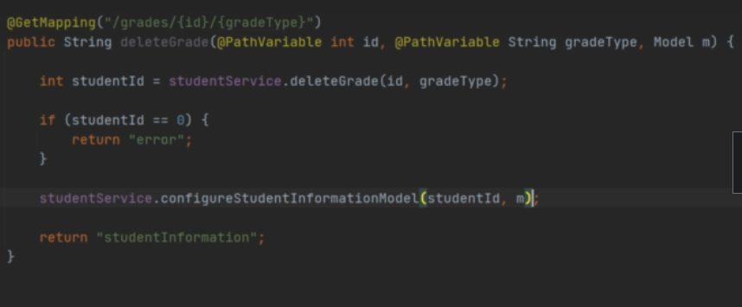

**DATABASE**

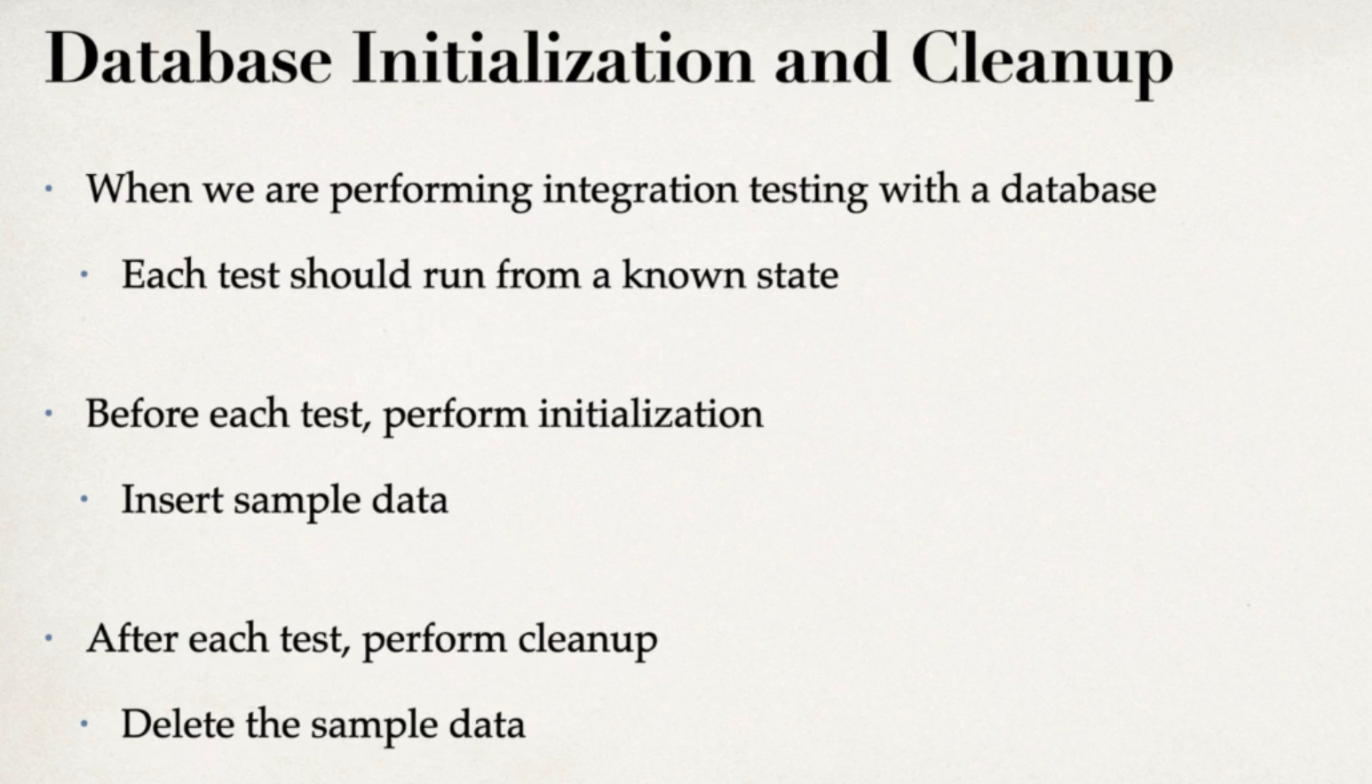

Using values from the application.properties

